|  |  |  |  |  |  |  |  |  |
| --- | --- | --- | --- | --- | --- | --- | --- | --- |
|  | | | | | | | | |
|  | | **Palo Alto Licensing/Operating System Upgrade Lab** | | | | |  | |
|  |  | | | | | | |  |
|  | | | |  |  | | | |
|  | | | | Weizhen Chen |  | | | |
|  | | | | —CCNP—Jeffery Mason &Michael Hansen |  | | | |
|  | | |  | | |  | | |

## Lab Partners: Paramon Yevstigneyev

Purpose

The objective of the lab was to update the Palo Alto (A220) firewall Pan OS to the latest version and retrieve licenses from Palo Alto Network using the management console.

Background information

Upgrading the Palo Alto Firewall to the latest PAN-OS release ensures it remains stable, safe from known vulnerabilities and exploits but also allows you to take advantage of new features of the latest update. Palo Alto Networks firewall needs to have a license in order to access and download the updates or other features.

Configurations

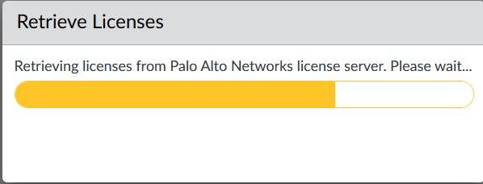

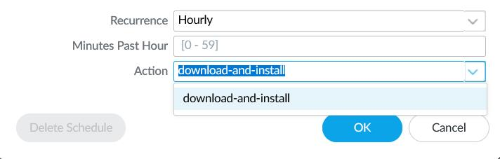

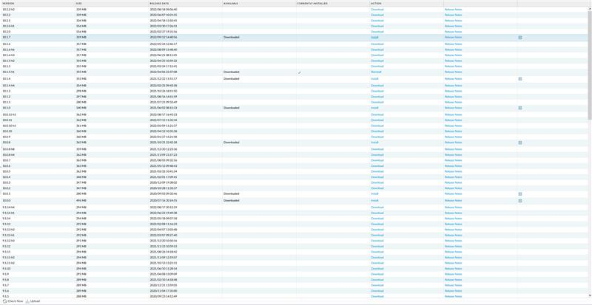

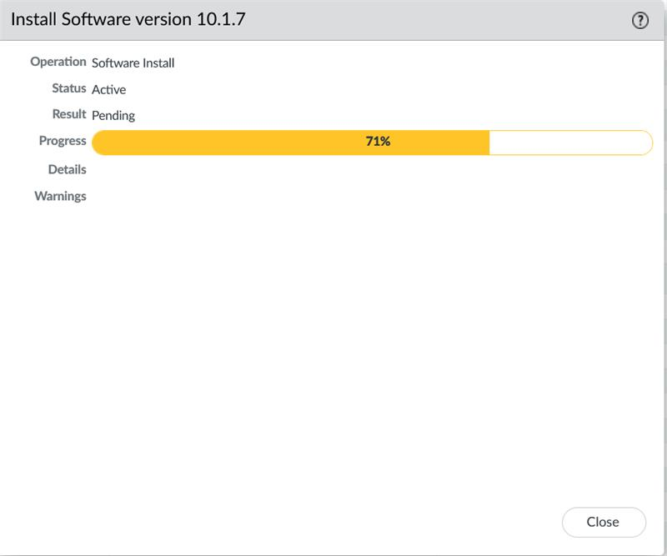

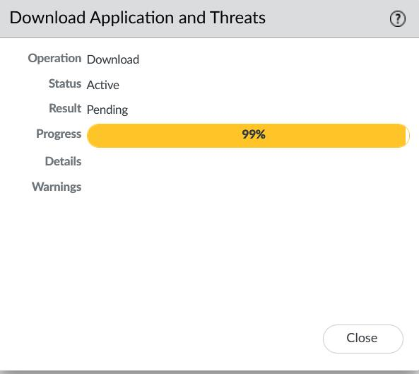

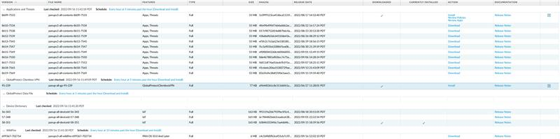

Problems

We have not encountered any major problems while configuring the OSPF lab. But we did encounter some small mistakes during the lab. One problem was that we Couldn’t check for updates, as it wasn’t connected to the internet. This was fixed by checking for any possible mistakes made when setting up a palo alto network. Second Problem was that we couldn’t check for Pan OS updates despite it being connected to the internet this was fixed by rebooting and checking for updates multiple times fixed it. Another small minor problem was that we downloaded some of the wrong software that wasn’t part of the update process, which slowed us down.

Conclusion

The objective of the lab was to be able to retrieve the Palo Alto Firewall license and upgrade the operating system. During this prosses of figuring out updates and license it allowed us to practice and allowed us to familiarize ourselves with Palo Alto Firewall management console. During the lab we encountered some small troubles that we learned from, but we were able to retrieve the license for the Palo Alto Firewall and upgrade the operating system to the latest version Firewall by the end.